**Business Problem**

An apartment rental search website would like to drive more traffic to their website by starting a blog. One post lists of the safest neighborhoods in Ottawa. The target audience are people looking to rent an apartment in the safest part of the city. There has been an increase in crime, so people are worried.

To find a list of the safest neighborhoods in Ottawa, crime rates will be analyzed for each neighborhood to find the safest ones. Three types of crimes will be used to determine the safest neighborhoods: crimes against property, crimes against people and other criminal offences. Another indicator of safety will be the number of police stations in the neighborhood.

**Data**

City of Ottawa crime data and Foursquare police station location data will be used to find the safest neighborhoods in the city.

Crime data was imported from a csv file provided by the City of Ottawa. The file has been edited and all columns removed except for neighborhood, population, crimes against people, crimes against property and other criminal offences. The ‘crimes against people’ column is in thousands, so each entry will be multiplied by a thousand to get the actual amount. The ‘crimes against property’ column is in two thousands, so each entry will be multiplied by two thousand. The ‘other crimes’ column is in three thousands, so each entry will be multiplied by three thousand. Crime columns were then rounded and converted in *‘int32’* types.

Latitude and longitudes locations were inputted using *‘Nominatim’* from *‘geopy.geocoders’* aswell as manually when the geolocator provided inaccurate location data.

The latitude and longitude data were then combined with the crime data into a single data frame.

Foursquare location data was used to find a data frame of the latitudes and longitudes of police stations in Ottawa. Entries of police stations outside of Ottawa and locations that were not police stations were removed from the data frame. *'Venue'* and *'Venue Category'* columns were dropped, *"Venue Latitude"* was renamed to "Latitude" and *"Venue Longitude"* renamed to *"Longitude"*. Police stations missing from the database were added using a list of the missing stations.

**Methodology**

The data was normalized into a common scale called the *neighborhood safety scale*. The *neighborhood safety scale* is calculated by adding up the total number of crimes in a neighborhood, the distance between the neighborhood and the closest police station and dividing by the number of people living in that neighborhood.

$$Neighborhood Safety Scale= \frac{C_{people} + C_{property}+ C_{other}+ D_{police}}{Neighborhood Population}$$

The distance between each neighborhood and its closest police station was calculated by iterating through each neighborhood and each police station. The method *‘geopy.distance.distance’* was used measure the distance between the two latitude, longitude coordinates in each iteration.

After calculating the *neighborhood safety scale* of each neighborhood, s*ort_values* and *head(10)* were used to display the ten safest neighborhoods in Ottawa. A choropleth map was also used display the *neighborhood safety scale* shaded proportionally over the neighborhoods in Ottawa. A horizontal bar chart was used to visualize the difference in the *neighborhood safety scale* in different neighborhoods.

**Results**

The safest neighborhoods were found to be the neighborhoods furthest from downtown core.

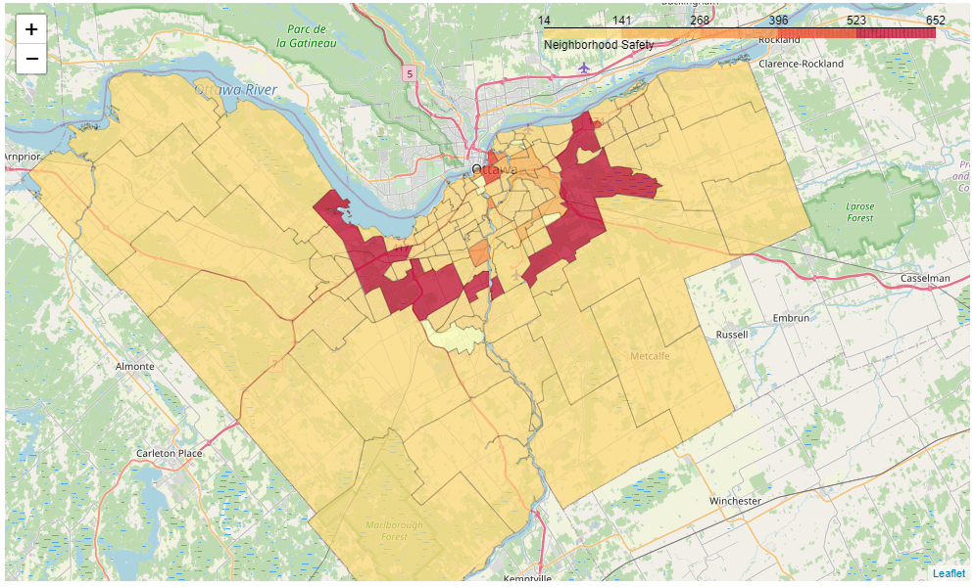

The most dangerous neighborhoods were the ones surrounding the downtown core.

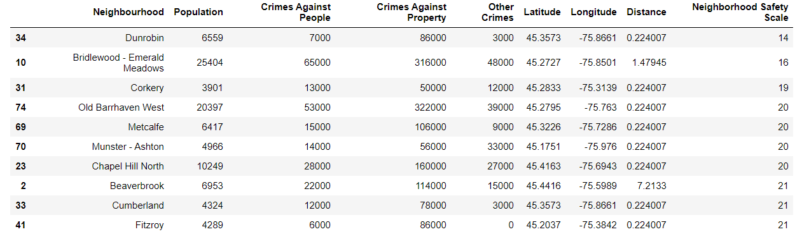

**Discussion**

Based on the results I recommend looking further into other indicators that may be affecting the safeness of a neighborhood besides proximity to the downtown core. For instance, household income, unemployment rate, city program funding and other indicators that are known to correlate with crime rate.

**Conclusion**

The safest neighborhoods in Ottawa were found to be the neighborhoods furthest from the city center. City crime rates were analyzed for each neighborhood. The safest neighborhood was found to be Dunrobin the neighborhood on the north-west corner of the city.